Tugas Aljabar Linear Matrix

1. Yasmin
2. Fikrul
3. Uus
4. Menentukan matrix A dan B

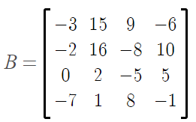

1. Menentukan OKE atau OBE 3 buah

K41(-3)(B) 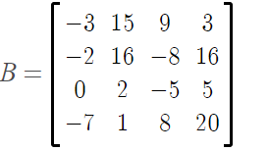

1. Menentukan equivalen antara matrix A dengan C dan B dengan D

Jadi A~C

 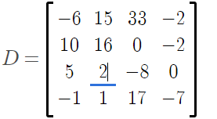

K14(B) 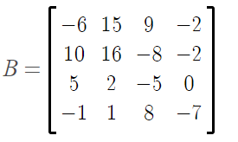K3(2)2(1)(B) 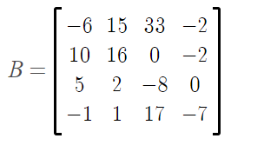

Jadi, B~D

1. Menentukan determinan matriks A menggunakan metode sarrus dan B menggunakan metode kofaktor.



Menentukan determinan matriks A:

$$\left|\begin{matrix}-1 & -2 & -3 \\ -4 & 0 & 1 \\ 2 & 3 & 4\end{matrix}\right|$$

Menggunakan metode sarrus



$$\left|\begin{matrix}-1 & -2 & -3 \\ -4 & 0 & 1 \\ 2 & 3 & 4\end{matrix}\right|$$

(1x0x4)+(-2x1x2)+(-3x-4x3)-(2x0x(-3))-(3x1x(-1))-(4x(-4)x(-2))=0+4+36-0+3-32=11

Menggunakan metode kofaktor



b11K11+ b12K12+b13K13+ b14K14=

-3 – 15+9- (-6)

=16(-35)-(-8)(-7)+10(21)= -406

$\left|\begin{matrix}-2 & -8 & 10 \\ 0 & -5 & 5 \\ -7 & 8 & -1\end{matrix}\right|$ = -2(-35)-(-8)(35)+10(-35)=0

$\left|\begin{matrix}-2 & 16 & 10 \\ 0 & 2 & 5 \\ -7 & 1 & -1\end{matrix}\right|$ = -2(-7)-16(35)+10(14)=-406

$\left|\begin{matrix}-2 & 16 & -8 \\ 0 & 2 & -5 \\ -7 & 1 & 8\end{matrix}\right|$ = -2(21)-16(-35)+(-8)(14)= 406

(-3)(-406)-15(0)+9(-406)-6(406)= 406(3-9+6)= 406.0 = 0

Jadi, det(B)=0

1. Menentukan Rank Matriks

karna tidak bisa dicari lagi, maka Rank (A)= 3

B3(1)4(1) 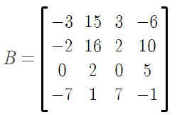B1(1)3(1) 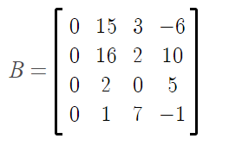

Maka, Rank(B)=3